**Ansible command arguments:**

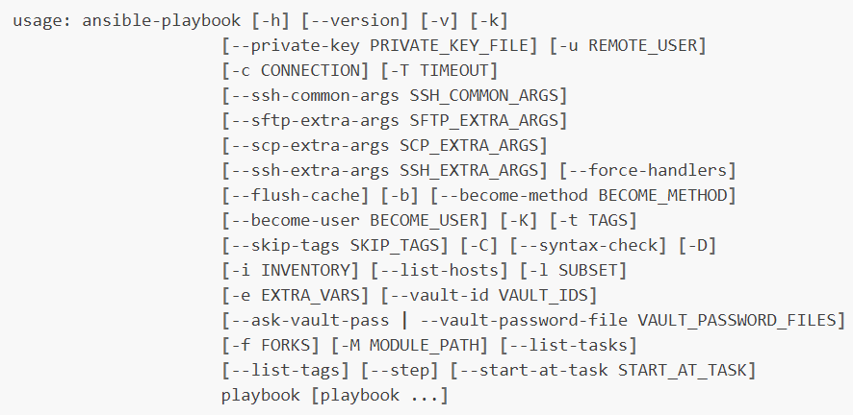

**Example:**

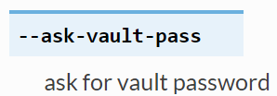

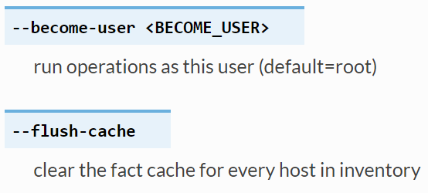

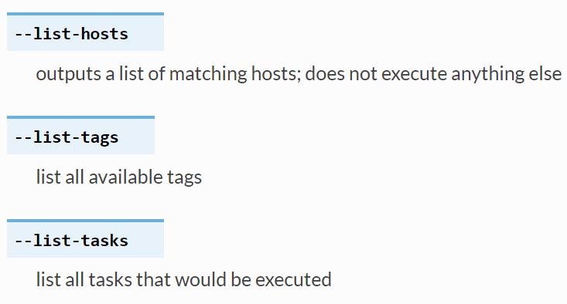

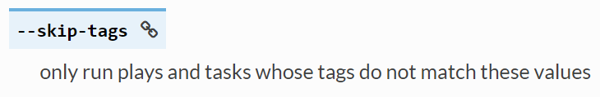

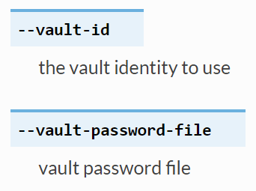

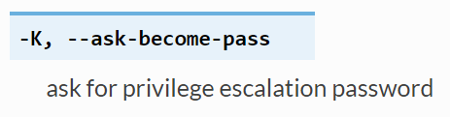

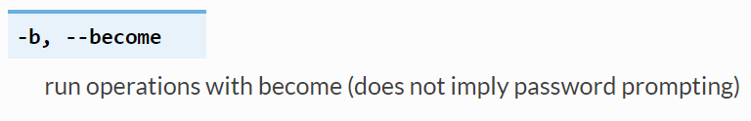

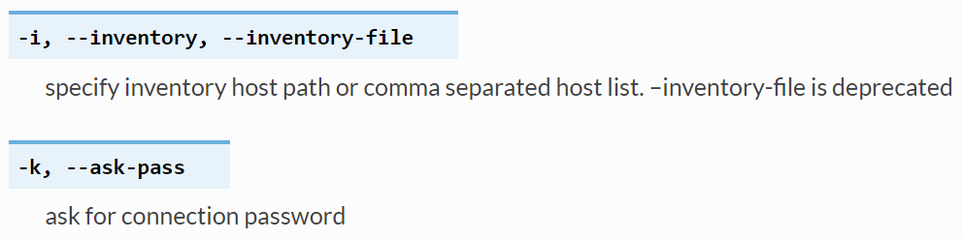

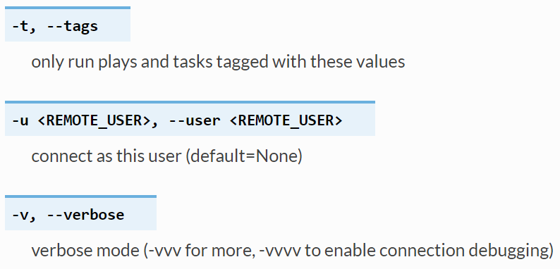

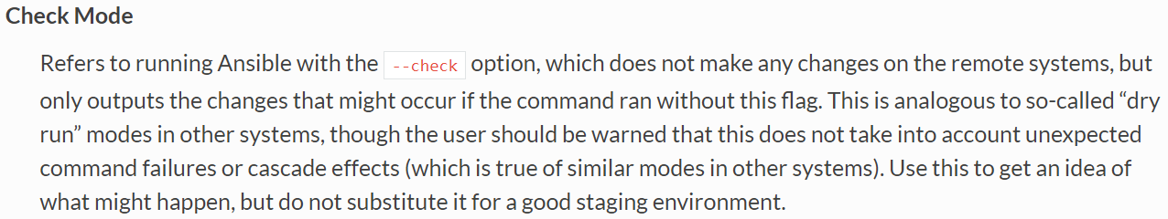

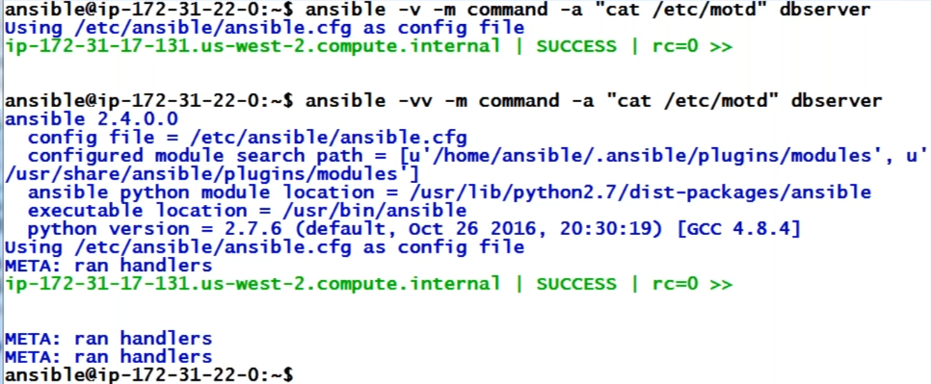

* If we give -v, it gives the config file location, python location, module details etc.

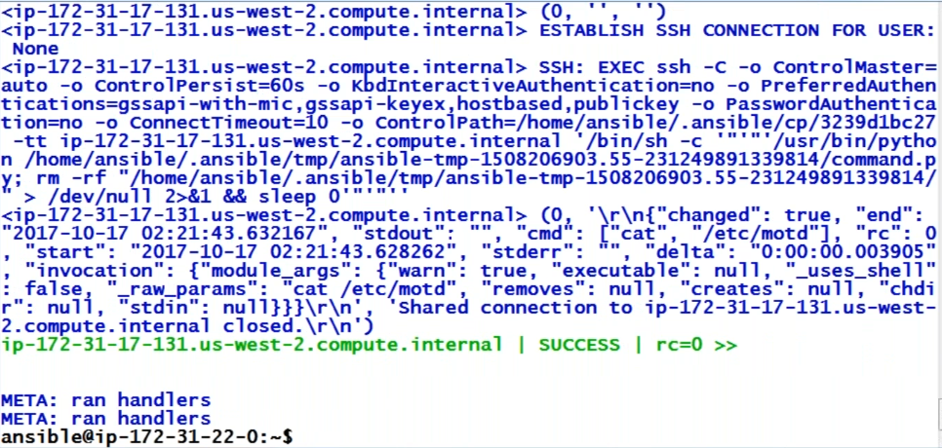

* If we give -vvv, it gives more elaborate data like what happened during ansible command execution
* With this, we can know how ansible works

**Ansible manual commands:**

**Command module:**

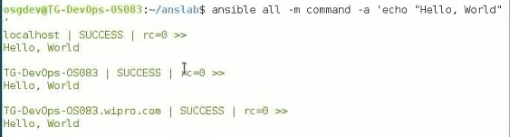

* As above, we did command manually, it is pushing the module command to remote servers and getting the output to source machine



* We can use the command module by just specifying with -a, by default it will take it as command module
* -a is argument here



**Creating file:**



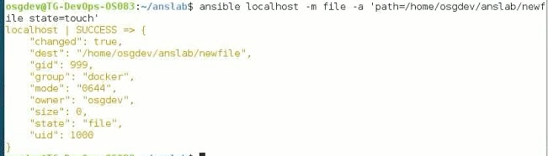

* As above, group and owner will be taken easily

**To create a directory**

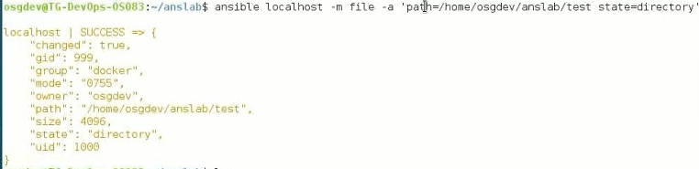

**Copy module manually:**

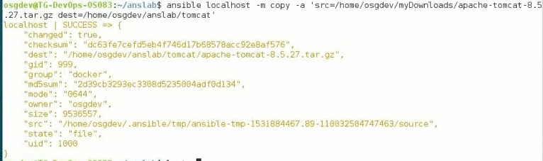

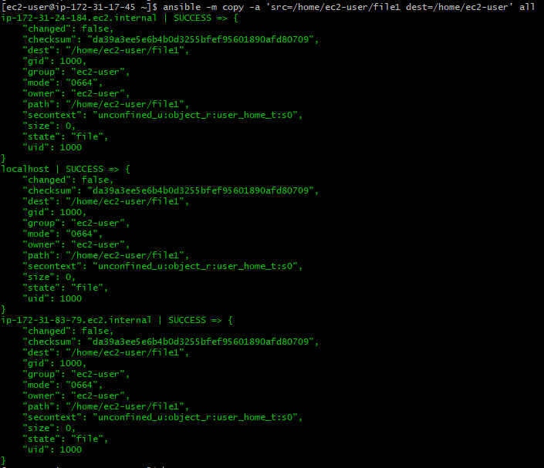

**Unarchive module manual:**



**Setup or gather facts:**

* This module is automatically called by playbooks to gather useful variables about remote hosts that can be used in playbooks. It can also be executed directly by /usr/bin/ansible to check what variables are available to a host. Ansible provides many facts about the system, automatically.
* This module is also supported for Windows targets

**Ansible -m setup dbserver**

* With above command, we can see the facts details of server which will be huge.
* We can use these facts in playbooks, we can get the details with the above command and use them
* Gather stats done automatically
* If we want to disable it, use **gather_facts=false** in yml file. Then the execution will be fast

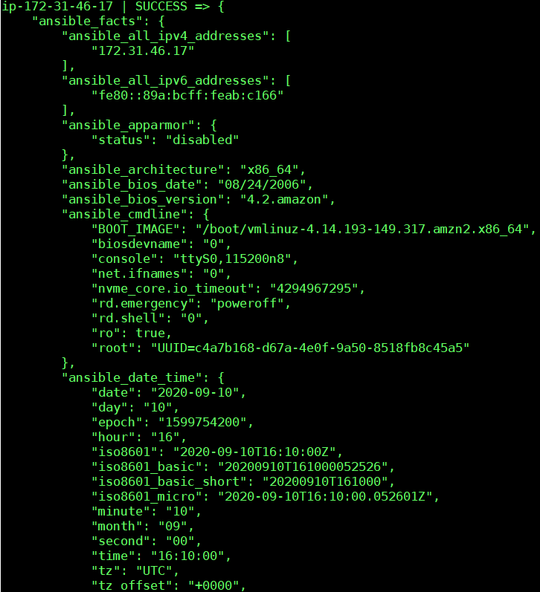

* Above is the small example how ansible displays gather facts. If we want specific details to be displayed. We need to filter as below.

**Filter gather facts:**

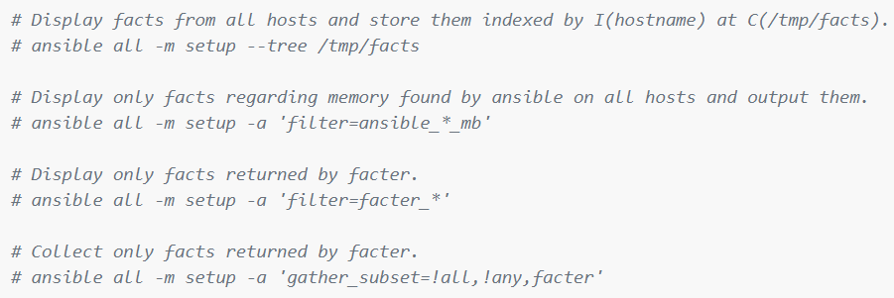

* **ansible all -m setup --tree /tmp/facts 🡪 to display to store facts in /tmp/facts**

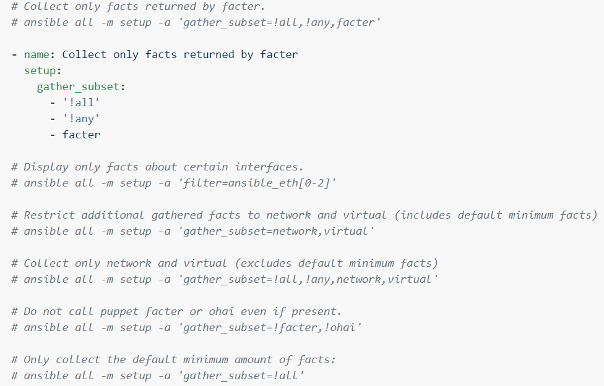

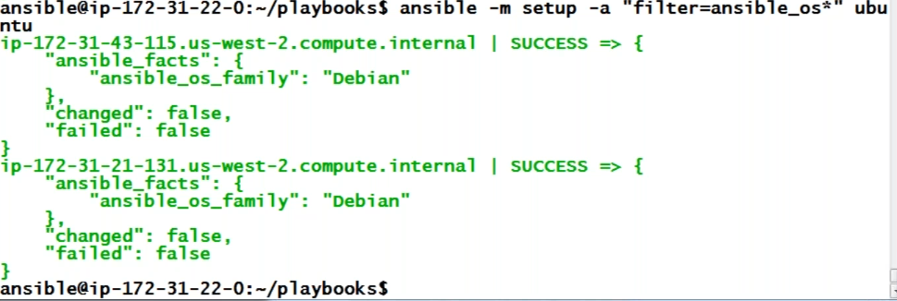

**Parameters:**

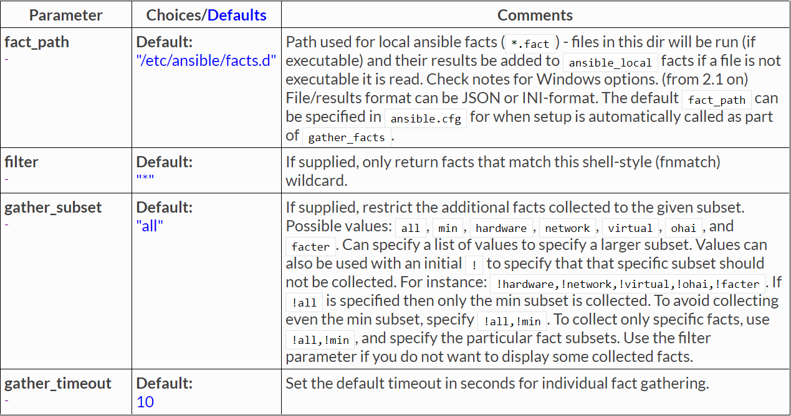

**Using gather facts in yaml file:**

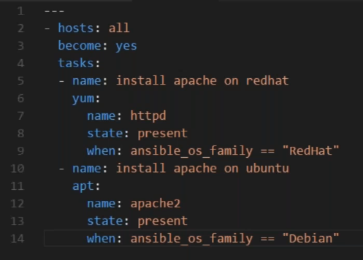

* We can make condition as above with facts
* For this, we need to go for condition, mostly we go with gather facts. check it and go for it

